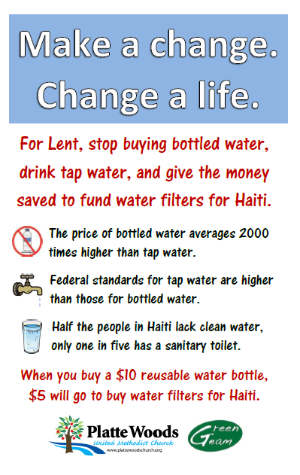
Platte Woods United Methodist
Green Team, Spring 2012

The PWUMC Green Team partnered with our pastoral leadership to conduct an exciting Lenten campaign. The sermon on March 25 focused on life-giving water in both the physical and spiritual sense. Once it is posted, the 2/25/2012 sermon can be viewed on the PWUMC website at: http//plattewoodschurch.org/418329.ihtml
Before Ash Wednesday, the Green Team covered the building with information about the harm caused by disposable plastic bottles, the issues around tap compared to bottled water quality and ownership, and worldwide needs for clean water and sanitation. We utilized 5 bulletin boards in the Church dining hall, placed fliers repeating much of the same information on tack strips throughout the building, and put small factoids up in all the bathroom stalls, over urinals, sinks and drinking fountains. We handed out cards with the Lenten challenge on Ash Wednesday and the first Sunday in Lent.
PWUMC purchased 300 reusable water bottles to sell as part of the campaign. The Green Team staffed the sales tables after services throughout Lent.
Pastoral support contributed a great deal to the success of this project and was particularly encouraging to Green Team members. The project also engaged the Mission Team who will lead a group to install Hydraid water filters in Haiti.
The Platte Woods Green Team would be happy to share our research and information resources with other Teams that might like to conduct a similar campaign sometime. Contact: Carol Adams, sactadams@yahoo.com

