**Putting Energy into Stewardship – Adopt a Light**



**Putting Energy into Stewardship**

**Energy Stewardship Project of**

**Grace Covenant Presbyterian Church**

**11100 College Blvd**

**Overland Park KS 66210**

Buildings consume about 40% of all electrical energy usage of which lighting is over 25% of those operating costs of a facility. This project was designed to reduce these costs to the congregation allowing for the monies saved to transfer from operating costs to other budget needs of the congregations such as outreach activities and donations. Although phase 1 of this project will cost ~ $6000.00 the annualized return is estimated to be more than 10% ROI. Energy-efficient lighting is economically feasible with a simple payback of < 4 years. Energy efficient lighting makes sense in a commercial building where lighting consumes 3X the cost of the electrical generation of air conditioning. Less energy used reduces carbon dioxide (CO2) emissions by 22.4 tons per year. This equals the energy emissions of 1¾ homes/year!

The Adopt-A-Light program within the Putting Energy into Stewardship was chosen as the first of the low hanging fruit opportunities to steward our investment. When it was proposed, the congregation was reviewing all budget items in light of the downturn in the economy. This Adopt-A-Light program was initiated to help save money in the utilities line item with the money saved to be repurposed to another vital area of the budget for the congregation.

In 2009 the Federal Environmental Protection Agency (EPA) developed new rules intended to reduce energy consumption and pollution (from mercury). They mandated that the manufacture of PCB containing magnetic ballasts and eight foot T-12 fluorescent tubes be discontinued. July of 2012 the Department of Energy mandated the phase out of production of T-12 tube, requiring the substitution of T-8 tubes in existing fixtures. The existing PCB ballasts can only be replaced with new electronic ballasts designed to run the T-8 tubes.

The Adopt-A-Light program was initiated to save money AND to abide by these new EPA and DOE rules.

What We Did

Mike Lorimer, one of our members of our KAIROS team and a GCPC congregational member – completed a comprehensive energy audit and inspection of the Church facility. One of his recommendations was to ‘retrofit’ the *Trofffer Lights* throughout the facility. *Trofffer Lights* are the ubiquitous lights used throughout commercial settings - the 4 bulb rectangular fixture usually installed in hanging ceilings. Retrofitting allowed for the reuse of the fixture. We decided to accomplish the retrofit of the facility in two phases which allowed time to raise the money and to use the removed bulbs as replacements for those fixtures identified as phase two changes. The retrofit kit included a new electronic ballast, a reflector and 2 T-12 4 foot bulbs.

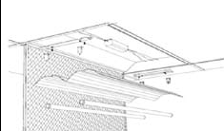

Adopt-A-Light was designed to replace these outdated bulbs with newer more energy efficient bulbs, reducing our electrical demand. This project will result in not only reducing utility costs up to 65% but also cut carbon dioxide/greenhouse gases emissions cut by 22.4 tons/yr. The program was scheduled to be completed in 2 phases. Phase 1, the most used areas of the facility, included storing the removed light bulbs to be used for replacement bulbs in phase 2 areas scheduled for retrofit. Volunteers of all ages were encouraged to come to work days with activities planned for all skills. A qualified electrician detached and removed from ceiling and re-attach fixtures. Volunteers from the congregation removed the existing T-12 bulbs; installed the reflector insert and new the new T-8 bulbs; made sure tools are available for those ‘retrofitting’; moved work tables from room to room during work day and performed other miscellaneous needs.

We launched the program through a series of announcements during services, announcements placed in monthly newsletter, posting of information on the bulletin board and installing a visual ‘tree’ for those who adopted, to place a tree leaf or acorn to ‘grow our tree’. It was estimated the full retrofit kit would be ~$50.00/light and we offered the congregation many ways to Adopt. They could adopt one full fixture (or more) or just the lights @ $25.00, or any portion they were able to donate. We were able to launch and raise the portion of funds needed for phase one within one month.

***Funding sources & Partnerships* (100 words)**

KAIROS received a $350.00 seed grant from PC (USA). Our remaining funding came from congregational members through our ‘Adopt a Light’ campaign. Donations were sought and encouraged by connecting utility savings to Outreach projects. For example: $50 donation would provide70 Harvesters meals every year, $100 donation would buy and install an energy efficient wood stove in Haiti every year just in the utility savings alone. The completed retrofit would allow us to almost double our Outreach budget.

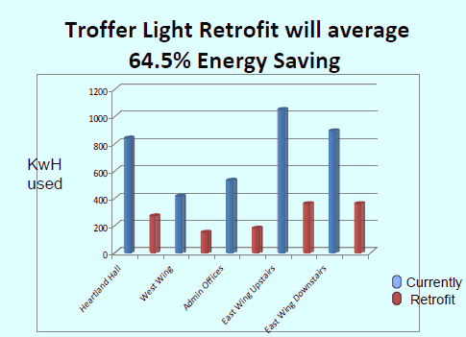

Chart identifying energy savings with retrofit

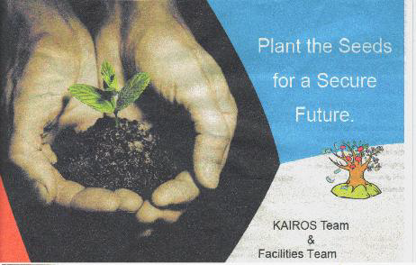

Front bulletin insert used to launch the project